Exploratory Testing and Bug Report
Bug ID | Severity | Priority | Steps to Reproduce | Expected vs Actual | Suggested Fix | screenshots
BUG-001 | Medium | Medium | 1. Navigate to Order Now.  2. Select a product with a Buy 1 Get 1 offer.  3. Click Add to Cart once.  4. Observe the cart badge count. | Expect  The cart badge should accurately represent the intended cart count  Actual: After adding one promotional item, the cart badge increases based on the total quantity (including the promotional item) | Define and implement a consistent rule for the cart badge. If the badge is intended to show purchased items or unique products, exclude automatically added promotional items from the count. If it is intended to show the total quantity, ensure this behavior is clearly communicated to users. | 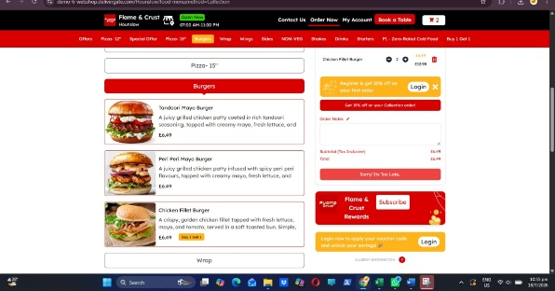
BUG-002 | Medium | High | 1. Open the Order Now page.  2. Add a large number of items to the cart (e.g., 15–20 items).  3. Open the cart popup.  4. Attempt to scroll through the list of items. | Expected: The cart popup should remain responsive and allow users to scroll through all items regardless of the number of products added.  Actual: After adding many items, the cart popup becomes unresponsive/frozen, and scrolling is not possible, preventing users from viewing all cart items. | Implement proper scrolling within the cart popup (e.g., a scrollable container with a maximum height). Ensure the popup remains responsive regardless of the number of items in the cart. | 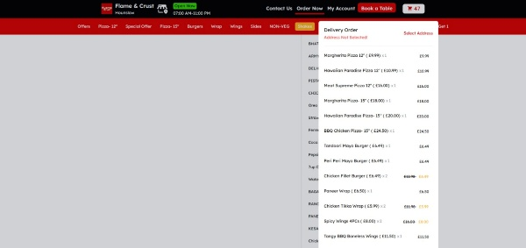
BUG-003 | Low | Medium | 1. Log in to the application.  2. Navigate to Checkout or Address Management.  3. Click Add New Address.  4. Observe the input fields in the popup. | Expected: All mandatory fields should be clearly marked (e.g., with a red asterisk *, "Required" label, or other visual indicator) so users know which information must be entered.  Actual: The popup does not clearly indicate which fields are required, making it difficult for users to identify the mandatory inputs before submitting the form. | Clearly identify mandatory fields using a consistent visual indicator (such as a red asterisk *) and provide inline validation messages when required fields are left empty. | 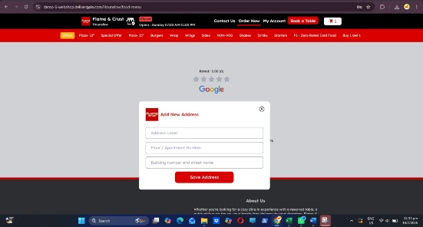
BUG-004 | High | High | 1. Log in to the application.  2. Navigate to Checkout or Address Management.  3. Click Add New Address.  4. Fill in all the required address fields with valid data.  5. Click the Save Address button. | Expected: The address should be saved successfully, the popup should close (or display a success message), and the new address should appear in the address list.  Actual: Clicking the Save Address button has no effect. The address is not saved, no success or error message is displayed, and the popup remains open. | Investigate the button's click event and form submission logic. Ensure the button is enabled after all mandatory fields are completed and provide appropriate success or validation feedback to the user. | 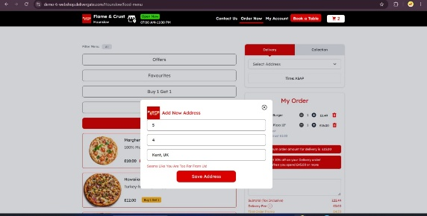
BUG-005 | Medium | Medium | 1. Log in to the application in Google Chrome using a registered account.  2. Add one or more items to the cart.  3. Log in to the same account using Microsoft Edge.  4. Open the shopping cart. | Expected: If the cart is account-based, the items added in Chrome should also be visible in Edge after logging in with the same account.  Actual: The shopping cart is empty in Edge, and the items added in Chrome are not synchronized. | Store cart information on the server and synchronize it with the user's account so that the cart is consistent across browsers and devices after login. | 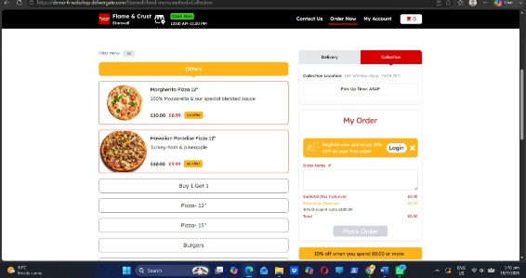
BUG-006 | Medium | Medium | 1. Log in to the application.  2. Navigate to Order Now.  3. Open Developer Tools (F12) → Network → Fetch/XHR.  4. Click Add to Cart for any product.  5. Open the corresponding API request and inspect the Preview and Response tabs. | Expected: The Add to Cart API should use the correct endpoint and return a response consistent with the performed action (e.g., cart details, updated quantity, success message).  Actual: Although the item is successfully added to the cart through the UI, the API endpoint/response/preview contains incorrect or inconsistent information that does not accurately represent the Add to Cart operation. | Verify that the correct API endpoint is invoked for the Add to Cart action and ensure the response payload and preview accurately reflect the operation performed. | 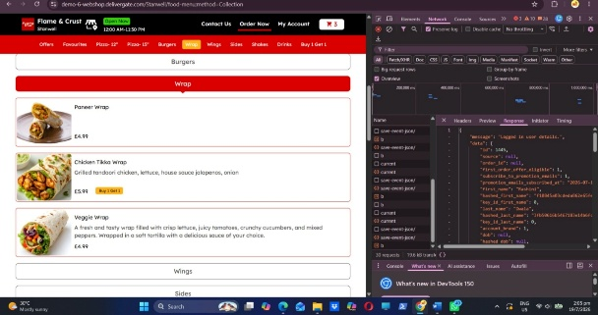
BUG-007 | High | High | 1. Open the Login page.  2. Enter a valid registered email address.  3. Enter an incorrect password.  4. Click Login.  5. Open Developer Tools → Network → Login API and inspect the response status code. | Expected: The API should return 401 Unauthorized (or 400 Bad Request, depending on the API design) with a clear error message such as "Invalid email or password". The UI should display an appropriate authentication error.  Actual: The API returns 500 Internal Server Error when invalid credentials are submitted, indicating an unexpected server-side error instead of an authentication failure. | Implement proper authentication error handling so that invalid credentials return an appropriate HTTP status code (e.g., 401 Unauthorized) and a clear error message without triggering a server error. | 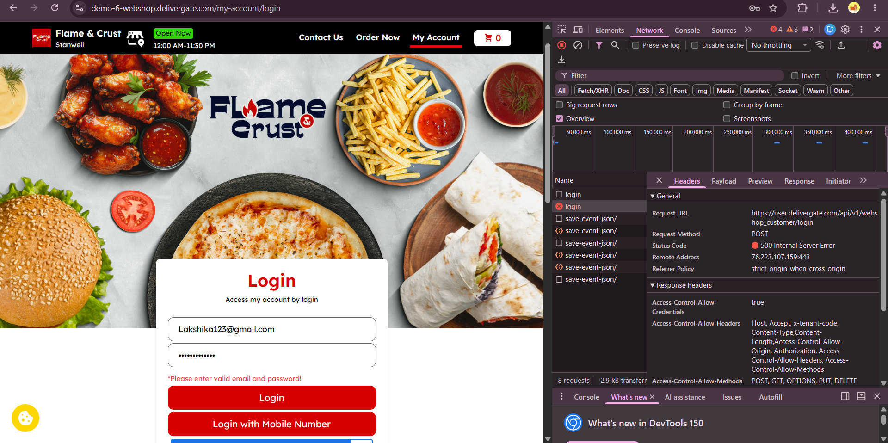
BUG-008 | Low | Medium | 1.Open the application.  2.Navigate to the menu section.  3.Open Browser DevTools → Network tab.  4.Check the API request used to fetch menu data. | Expected Result:  Application should use the correct documented menu API endpoint.  Actual Result:  Menu details are retrieved using /mobileapp endpoint. | Replace the incorrect /mobileapp endpoint with the correct menu API endpoint and verify the request-response flow through API testing. | 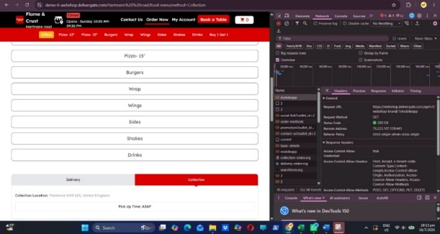
BUG-009 | Medium | Medium | 1. Create a user account.  2.Delete the account.  3.Attempt to log in using the deleted account credentials.  4.Check the API response status code. | Actual Result:  After deleting the account, login API returns an incorrect status code (e.g., 500 Internal Server Error).  Expected Result:  System should return 401 Unauthorized when attempting to log in with deleted account credentials. | Add proper exception handling for deleted/inactive users in the login API. Return a valid authentication error response instead of allowing an unhandled server exception to generate a 500 response. | 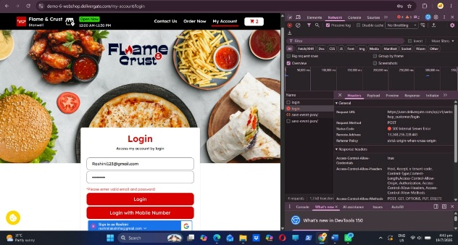
BUG-010 | High | High | 1.Create Account A.  2.Add items to the cart.  3. Delete Account A.  4.Create/Login with Account B using a new account.  5.Navigate to the cart. | Expected Result:  The new account should have an empty cart. Cart data should be isolated and linked only to the respective user account.  Actual Result:  Cart items from the deleted account are displayed in the new account. | Clear cart data when an account is deleted.  Ensure cart records are mapped using a unique user ID.  Clear browser/session storage after logout or account deletion.  Verify that a newly created account starts with a fresh cart. | 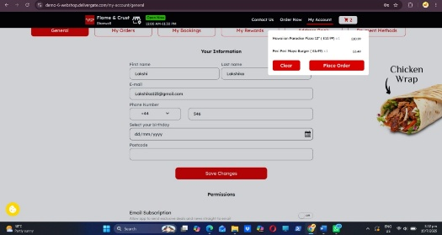
BUG-011 | Medium | Medium | 1.Open the application.  2.Log in with a valid user account.  3. Navigate to the home page.  4.Check the top navigation bar/header. | Expected Result:  Profile icon or user account information should be displayed on the home page after successful login.  Actual Result:  Profile icon/user account indicator is not displayed. | Display the profile icon after successful authentication and ensure the UI correctly retrieves and shows the logged-in user's account information from the session/token. | 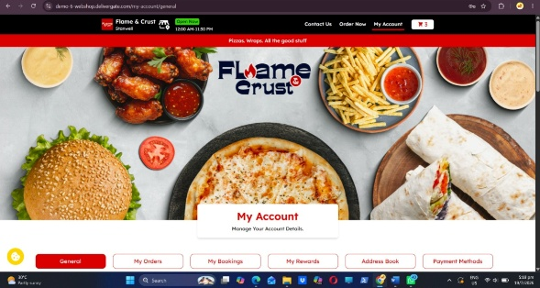
BUG-012 | High | High | 1. Login with User A.  2. Add items to the cart.  3. Logout from User A.  4.Login with User B.  5. Navigate to the cart. | Expected Result:  Each user should have an independent cart. User B should only see items added to their own account.  Actual Result:  User B can see User A's cart items. | Clear cart data from local storage/session storage during logout.  Associate cart records with the authenticated user's unique ID.  Fetch cart data based on the current logged-in user only.  Clear previous user session/token data after logout.  Add test cases for switching between multiple user accounts. | 